**Supply Chain Analysis**

In this case study, I analyze historical data from a Supply Chain company in order to identify trends in how their customers order products differently. The main tools we used was Power BI.

A more in-depth breakdown of the case study scenario is included below, followed by my full report.

**Scenario**

A **global retail company** sells products across multiple regions, including Europe, Latin America (LATAM), and Pacific Asia. They deal in various product categories such as Sporting Goods, Women's Apparel, and Fitness. The company operates two main warehouses in Puerto Rico and the USA, which handle the storage and shipment of products to customers worldwide.

**Defining the problem**

They face several supply chain challenges:

1. **Order Fulfillment**: They need to ensure timely deliveries, but inconsistencies in shipment modes and fulfillment times lead to customer dissatisfaction.
2. **Inventory Management**: They have varying levels of inventory across different months and regions, leading to overstocking or stockouts, which impacts profitability.
3. **Seasonality**: They observe fluctuations in order volumes, particularly during peak seasons (e.g., holidays), but they struggle to forecast and prepare for these changes.

**Business task**

The company wants to improve the efficiency of their supply chain by:

* **Analyzing shipment performance across different regions and shipment modes.**
* **What is the average fulfillment time for orders, and how does it impact overall warehouse performance?**
* **Understanding the impact of seasonality on sales and profitability to better prepare for demand fluctuations.**

Using this data, they aim to build a dashboard that provides insights into order fulfillment rates, inventory management, and seasonal trends, enabling more informed decision-making and smoother operations across the supply chain.

**Data Source**

Supply chain data that is made publicly available by the **DataCamp** will also be used. In terms of bias and credibility, the data sources we are using ROCCC:

* **Reliable and original:** this is public data that contains accurate, complete and unbiased info on Cyclistic’s historical bike trips. It can be used to explore how different customer types are using Cyclistic bikes.
* **Comprehensive and current:** these sources contain all the data needed to understand the different ways members and casual riders use Cyclistic bikes. The data is from the past 12 months. It is current and relevant to the task at hand. This is important because the usefulness of data decreases as time passes.
* **Cited:** these sources are publicly available data provided by Cyclistic and the City of Chicago. Governmental agency data and vetted public data are typically good sources of data.

**Data cleaning and manipulation**

### **Power Query: initial data cleaning and manipulation**

Our next step is making sure the data is stored appropriately and prepared for analysis. After downloading the zip files and unzipping them, I housed the files in a temporary folder on my desktop. The dataset is separated into 3 main folders:

1. **Inventory.csv**
2. **Fullfilment.csv**
3. **Orders and shipments.csv**

After uploading the 3 files into power BI, we began inspecting each file for cleaning and to prepare it for manipulation.

**Data Cleaning**

The first steps we did after loading the data into power query are:

1. Checked all columns data type to its appropriate type to ensure prevent any problems that may occurs in the future.
2. We checked the tables for any duplicated rows to ensure accuracy of our insights and recommendations.

Some of the problems that we found was:

1. The date format in the inventory table was **(201507)** which is wrong so to resolve this issue we:
   * + Split the column by position to isolate the correct values.
     + Merged the necessary columns back together to reconstruct the date to the right format **(2015/07)**
2. Also, the order date column and shipment date column in order and shipment table have the same wrong date format **(201507)** so we used the same method as before to resolve this issue.
3. Some cells in the Discount column contain negative (-) values, So To resolve this issue we:
   * + Replace the value containing a negative (-) sign with (0).

**Data Manipulation**

After the data cleaning we started the data manipulations by preparing the available data to be used in a star scheme model. We created:

1. The Fulfillment table has been transformed into fulfillment|Dim and connected to the Fact Table via the **Fulfillment ID** (index column).
2. The Inventory table has been transformed into Inventory|Dim and connected to the Fact Table via the **Inventory ID** (index column).
3. Customer|Dim which contain all customers information and connected to the Fact Table via the **Customer ID** (index column).
4. Product|Dim which contain all customers information and connected to the Fact Table via the **Product ID** (index column).
5. shipment|Dim which contain all customers information and connected to the Fact Table via the **shipment days-scheduled**.
6. a date|Dim as a role-playing dimension table that connect with fact table by a one active relationship (order date column) and two inactive relationship (shipment date and inventory date).
7. Orders|fact which contain the rest of the columns and we linked all the dim tables to it.

After we created all these tables, we connected the together using the index columns in (dim tables) with the appropriate column in (fact tables) via merge quires to create the star scheme.

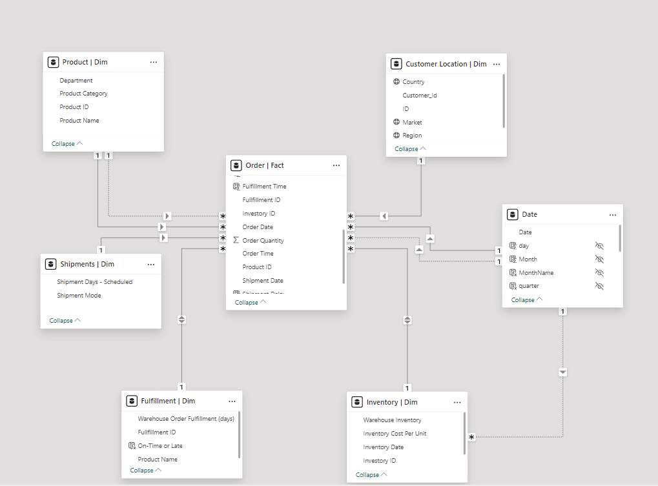

**Analysis Summary**

Based on our first impression we divided our analysis into two main dashboards each one answers its own set of questions.

**Dashboard #1: Shipment Overview**

Which includes:

* Filter bar on the left-hand side which enables us to filter our data based on (year, department, country and shipping mode).

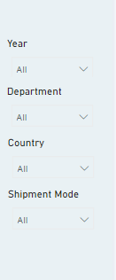

* An overview of the most important KPIs that will assess our company performance.

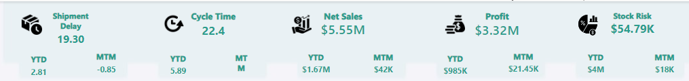

## these KPIs indicates that We have:

1. **$3.32M** in profitswith positive numbers in **MTM** and **YTD** KPIs.
2. $5.55M in gross sales also with positive numbers in **MTM** and **YTD** KPIs.
3. Average shipment delays of 19.3 days which isn’t a small period.
4. Average cycle times of 22.4 days which need to be improved

* A line charts that show average KPIs by months over the span of the 3 years (2015, 2016 and 2017)

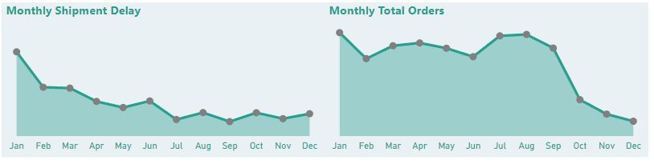

## the charts show

1. big difference in Avg. shipment delays in **Jan** compared to the rest of the year with the lowest number in **Dec** (which may be caused by the large number of **total orders** also in **Jan** and may be due to the **annual holiday of the new year**).
2. Autumn is the seasons with most orders.
3. Inventory turnover rate is present and needs to be addressed.

* LATAM is the highest profit generating market while Europe has the highest net sales.

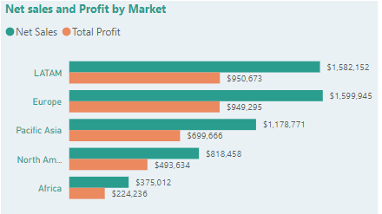

* **56.46%** of orders were shipped on time and the rest were late shipments.

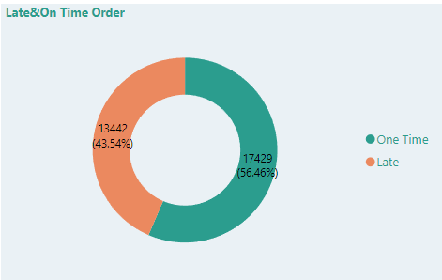

## this may be caused by long (inventory turnover rate).

* World map with countries (represented as dots) which order the countries from (the highest Avg. shipment delays (Big dots)) to (the lowest Avg. shipment delays (small dots)).

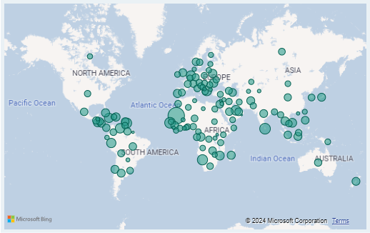

**Dashboard #2: Customer Overview**

Which includes:

* The same filter bar to navigate the data as needed

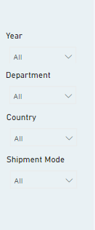

* Total customers with an average of cost per order

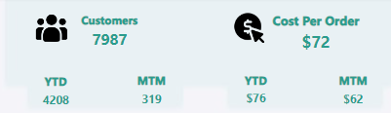

* The end of the year is the period with the least orders and customer count

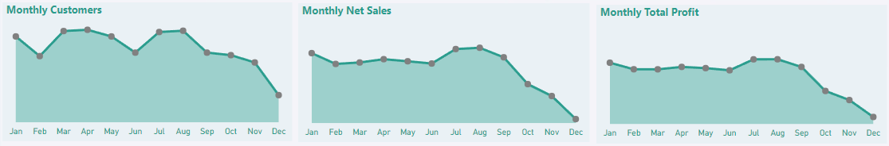

## improved delivery times and product offers may correct this pattern.

* Bar chart indicates that most of our customers choose (standard shipping)

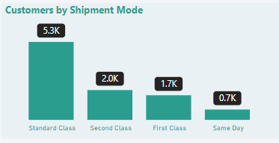

## other shipment methods charges may be high so decrease these charges or offer better shipping method on large orders my improve these numbers.

* Standard shipping has the highest numbers of item shipped

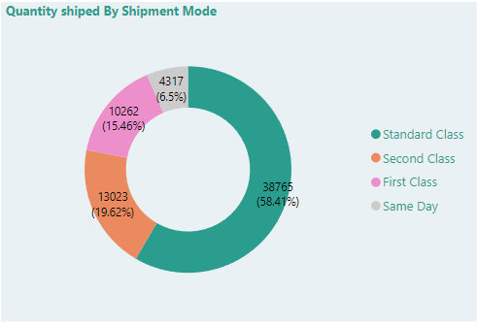

## which support our theory that offering better shipment on large orders will make more people to spend more or at least be familiar with higher tier shipping methods.

* World map with countries (represented as dots) which order the countries from (the highest Total Customers (Big dots)) to (the lowest Total Customers (small dots)))

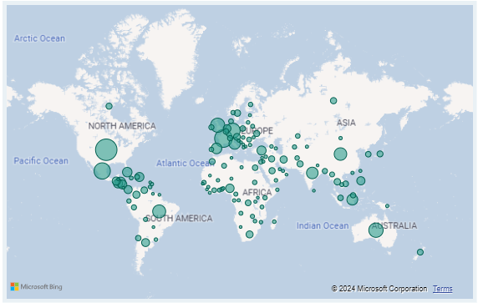

**Insights**

* Departments are experiencing delays in warehouse order fulfillment, with completion times ranging from **4 to 7** days, affecting timely delivery.
* Regarding shipment methods:
  + First Class:
    - Over the past three years, **89%** of total orders experienced delays, with an average delay of 19 days.
    - In 2017, **83%** of orders faced delays, averaging between 3 to 4 days.
  + Same Day:
    - Over the past three years, **21%** of total orders were delayed, with an average delay of 15 days.
    - In 2017, **18%** of orders experienced delays, averaging between 1 to 2 days.
  + Second Class:
    - Over the past three years, **56%** of total orders encountered delays, with an average delay of 18 days.
    - In 2017, **51%** of orders were delayed, with an average delay of 3 to 4 days.
  + Standard Class:
    - Over the past three years, **29%** of total orders were delayed, with an average delay of 20 days.
    - In 2017, **25%** of orders experienced delays, with an average delay of 2 to 3 days.
* Shipment delay were a major cause in profit loss.
  + In 2017, the company experienced significant losses in orders and sales across various shipment modes:
    - First Class: The company lost **550** orders, resulting in a sales loss of **$42,000**.
    - Same Day: A total of **176** orders were lost, translating to a sales loss of **$32,000**.
    - Second Class: The company lost **433** orders, with a corresponding sales loss of **$64,000**.
    - Standard Class: The largest loss was in standard shipping, with **1,251** orders lost, amounting to **$22,000** in lost sales
  + Overall, the company lost **2,410** orders, equating to **$160,000** in sales for the year 2017.

**Recommendations**

1. Optimize Shipment Modes:
   1. Standardize shipment modes for specific types of orders to improve consistency in delivery times.
   2. Explore partnerships with reliable carriers to ensure quicker and more consistent shipping options.
2. Enhance Fulfillment Processes:
   1. Streamline internal processes to reduce order processing times, such as implementing better inventory management systems.
   2. Consider automating parts of the fulfillment process where possible to reduce manual errors and speed up processing.
3. Set Clear Expectations:
   1. Improve communication with customers regarding expected delivery times and any potential delays.
   2. Provide real-time tracking updates to enhance customer confidence in the delivery process.
4. Monitor and Adapt:
   1. Continuously monitor fulfillment performance metrics and gather customer feedback to adapt strategies as needed.
   2. Regularly review and analyze shipping data to identify patterns and make data-driven adjustments.
5. Warehouse construction:
   1. France and Germany are both our biggest sales and profit generating countries. So, consider building a new warehouse in Europe in minimize the delays therefore increase the sales.

**Conclusion**

**Stakeholder presentation and dashboard**

We’ve provided our dashboard and shareholder presentation, which includes the following:

* A summary of my analysis
* Supporting visualizations and key findings
* Three recommendations based on my analysis